# Data Structure - Breadth First Traversal

Here we will discuss the techniques by using which, we can traverse all the vertices of the graph.

Traversal means visiting all the nodes of a graph. There are two standard methods by using which, we can traverse the graphs. Let’s discuss each one of them in detail.

1. Breadth First Search
2. Depth First Search

## Breadth First Search (BFS) Algorithm

Breadth first search is a graph traversal algorithm that starts traversing the graph from root node and explores all the neighbouring nodes. Then, it selects the nearest node and explore all the unexplored nodes. The algorithm follows the same process for each of the nearest nodes until it finds the goal. The data structure which is being used in DFS is queue.

## **BFS algorithm**

A standard BFS implementation puts each vertex of the graph into one of two categories:

1. Visited
2. Not Visited

The purpose of the algorithm is to mark each vertex as visited while avoiding cycles.

The algorithm works as follows:

1. Start by putting any one of the graph's vertices at the back of a queue.
2. Take the front item of the queue and add it to the visited list.
3. Create a list of that vertex's adjacent nodes. Add the ones which aren't in the visited list to the back of the queue.
4. Keep repeating steps 2 and 3 until the queue is empty.

## **BFS example**

Let's see how the Breadth First Search algorithm works with an example. We use an undirected graph with 5 vertices.

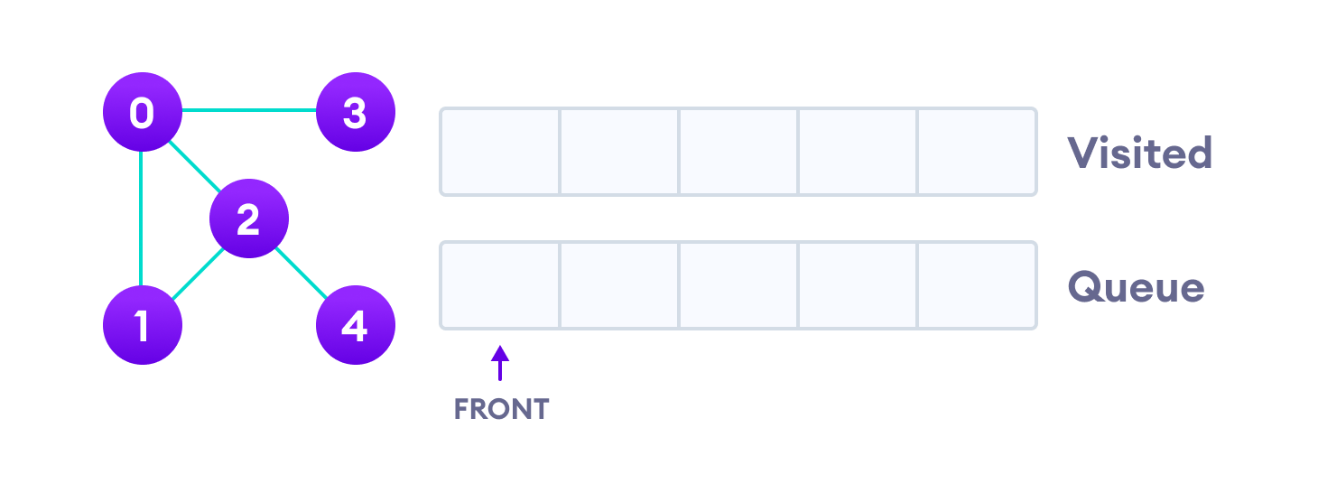Undirected graph with 5 vertices

We start from vertex 0, the BFS algorithm starts by putting it in the Visited list and putting all its adjacent vertices in the queue.

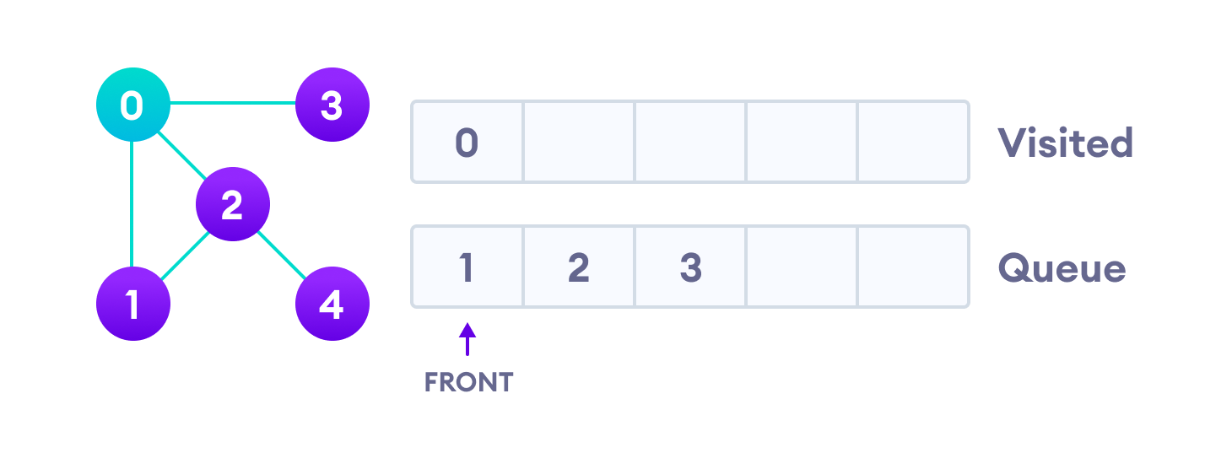Visit start vertex and add its adjacent vertices to queue

Next, we visit the element at the front of queue i.e. 1 and go to its adjacent nodes. Since 0 has already been visited, we visit 2 instead.

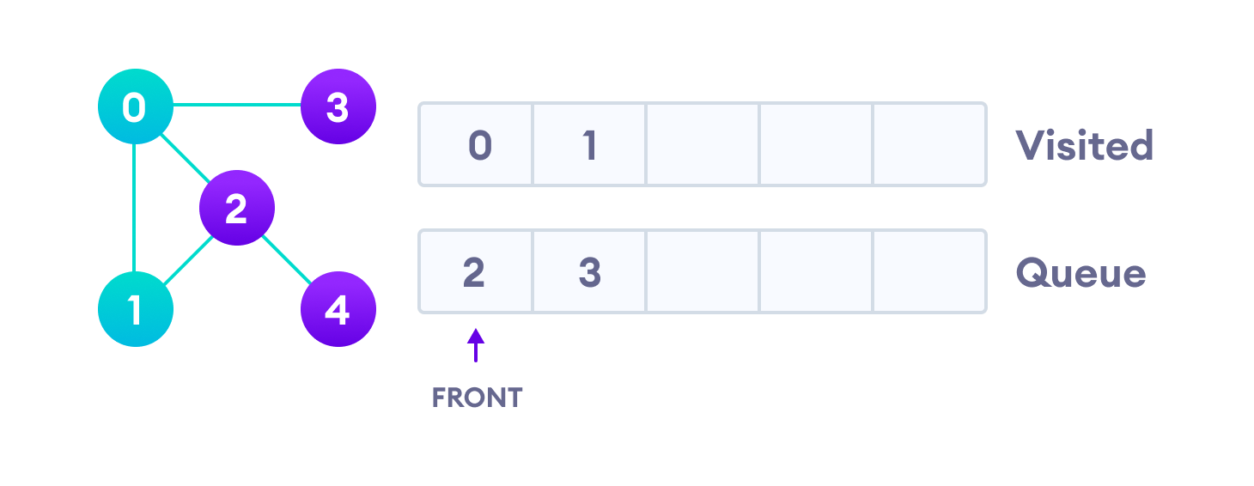Visit the first neighbour of start node 0, which is 1

Vertex 2 has an unvisited adjacent vertex in 4, so we add that to the back of the queue and visit 3, which is at the front of the queue.

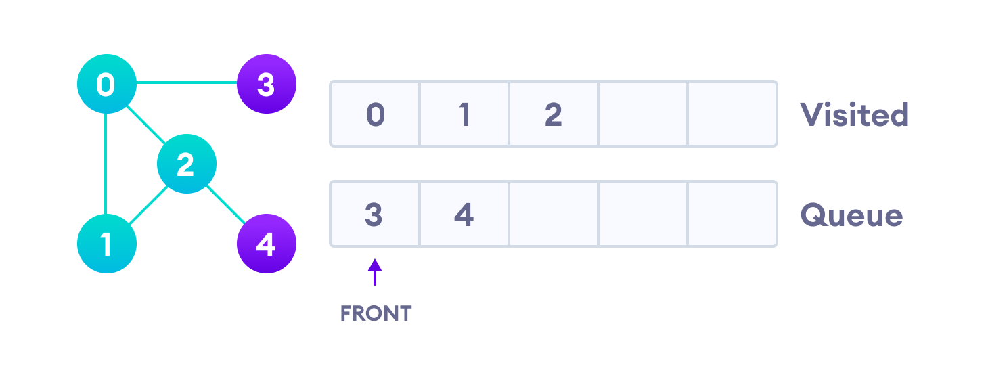Visit 2 which was added to queue earlier to add its neighbours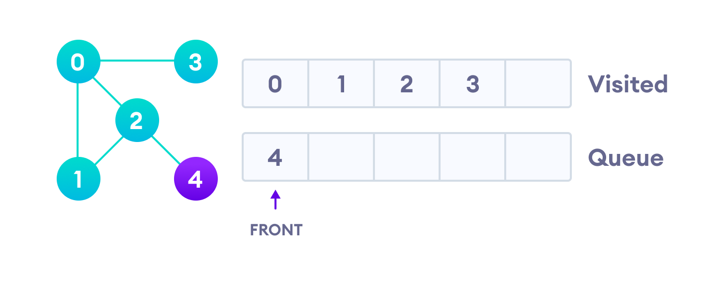4 remains in the queue

Only 4 remains in the queue since the only adjacent node of 3 i.e. 0 is already visited. We visit it.

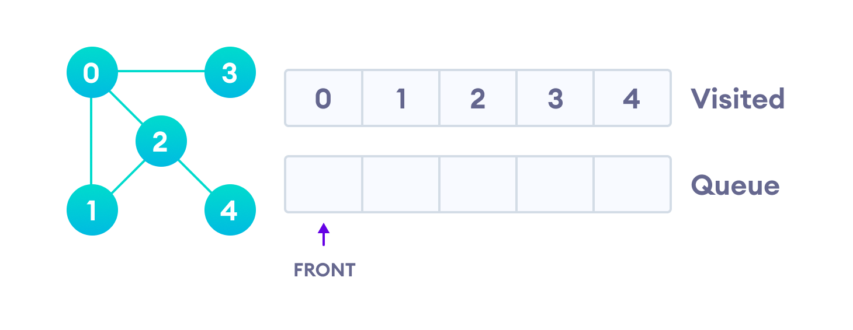Visit last remaining item in the stack to check if it has unvisited neighbors

Since the queue is empty, we have completed the Breadth First Traversal of the graph.

## **BFS Algorithm Complexity**

The time complexity of the BFS algorithm is represented in the form of O(V + E), where V is the number of nodes and E is the number of edges.

The space complexity of the algorithm is O(V).

## **BFS Algorithm Applications**

1. To build index by search index
2. For GPS navigation
3. Path finding algorithms
4. In Ford-Fulkerson algorithm to find maximum flow in a network
5. Cycle detection in an undirected graph
6. In [minimum spanning tre](https://www.programiz.com/dsa/spanning-tree-and-minimum-spanning-tree)e algorithm